**Count Frequency of Elements**

Problem

Given an array a[] of size n, our task is to find the frequency of each element in the array.

Example



In the above array, frequency of elements is

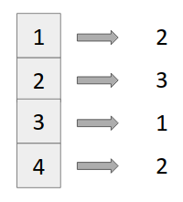

Answer

Steps

1. Declare a map (say freq) of both keys and value as int.

*map<int,int> freq;*

1. Iterate over the elements of the array and in each iteration just do,

*freq[a[i]]++;*

Imagination of freq map should be like this in your mind

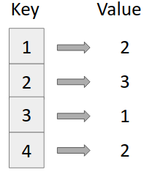

*freq map*

Code

